

chamber of commerce

Mormant Ile de France



July 7, 2021

[Company name]

[Company address]

**Final Project Web site plan**

**Site Name: Mormant chamber of Commerce**

**Site purpose:**

The best way to spread the word about your business is by making connections. We will make the chamber of commerce a place of unity, for businesses even among competitors. Local chambers will tackle both issues and trends taking place in the community as well as offer resources and services to help local businesses succeed.

**Target audience:**

**Personas:**

|  |  |
| --- | --- |
|  | **Sylvain** is 30, lives and works in Mormant. He is married, has 2 children and is often kept busy with balancing work and family life. He is a small business owner and is  looking for ways of promoting his business.  He is not comfortable with technology so he meets up with members of the chamber of commerce.  He likes to network when he has spare time but lately his kids have been keeping him busy.  Spending time with his family and going to local events in the area is one of the thins that he loves doing.  **Goal:** Stay in direct contact with fellow business owners.  Directly market to people who may require his products or services. |
|  | Isabelle is 28, lives in the city and works in the city. Isabelle is single, has no children and is often kept busy with work and catching up with friends.   She is a new event organizer who is enjoying her new job, even if she’s still establishing herself at her company.  **She is motivated by wanting to impress her colleagues and bosses**  **Goals:**  **-Wants to grow and prosper her business**  -Increase job opportunities. |

**Site map**

**Color scheme / Typography:**

|  |  |  |  |  |
| --- | --- | --- | --- | --- |
| **Header** |  | #B8B8F3 | **SAMPLE** | **GEORGIA** |
| **Navigation** |  | #2E4057 | **SAMPLE** | **GEORGIA** |
| **Body** |  | #E0E0E0 | SAMPLE | GEORGIA |
| **Headings** |  | #000000 | **SAMPLE** | **GEORGIA** |
| **Headings** |  | #000000 | **SAPMLE** | **GEORGIA** |
| **Paragraph text** |  | #000000 | SAMPLE | GEORGIA |
| **footer** |  | #B8B8F3 | SAPME | GEORGIA |

**Typography:**

**I will be using Georgia for the fonts in the webpage.**

**Wireframe sketches**:

Browser view wireframe

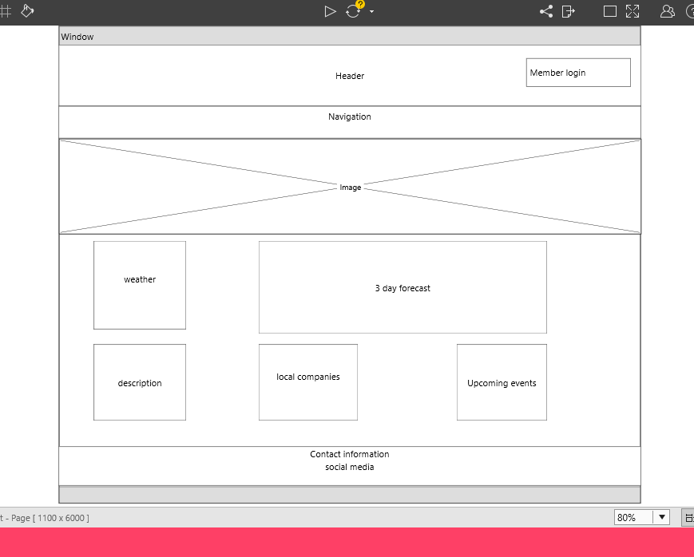

**Mobile view wireframe**

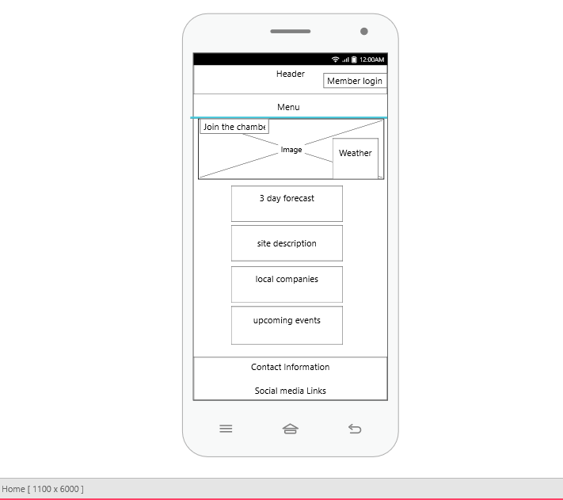

**Tablet View Wireframe**

